**IOT**

**NAME: SURIYAKALA V**

**REG NO: 212019106020**

**Circuit with piezo alarm, PIR sensor and temperature sensor**

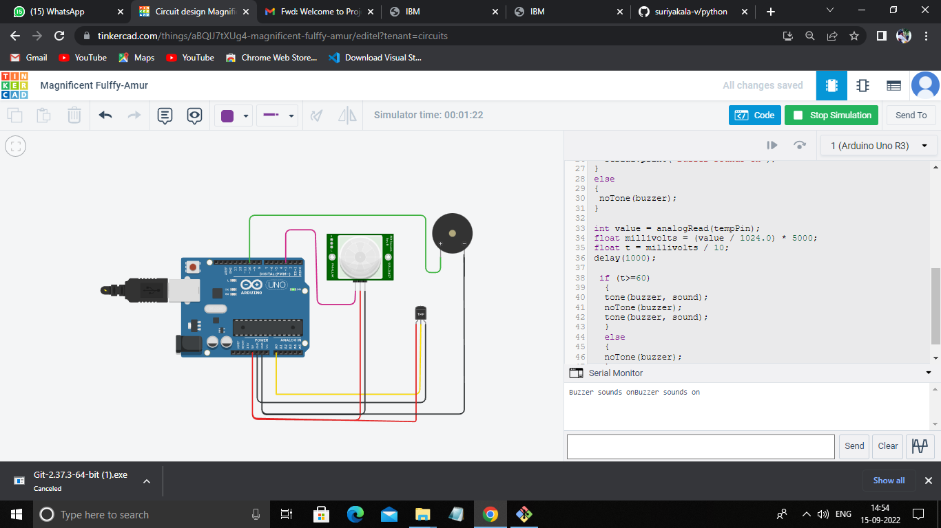

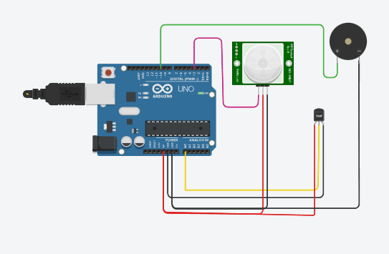

*Coding:*

const int tempPin = A0;

#define buzzer 10

int sound = 250;

int sound1 = 500;

int PIR= 3;

int val= 0;

int value= LOW;

void setup()

{

pinMode(buzzer, OUTPUT);

pinMode(PIR, INPUT);

pinMode(tempPin, INPUT);

Serial.begin(9600);

}

void loop()

{

val = digitalRead(PIR);

if(val == HIGH)

{

tone(buzzer, sound1);

noTone(buzzer);

tone(buzzer, sound1);

}

else

{

noTone(buzzer);

}

int value = analogRead(tempPin);

float millivolts = (value / 1024.0) * 5000;

float t = millivolts / 10;

delay(1000);

if (t>=60)

{

tone(buzzer, sound);

noTone(buzzer);

tone(buzzer, sound);

}

else

{

noTone(buzzer);

}

}